Student’s name | …………………………………………………….…… | Grade | 1
Subject | Computer | Week No. | 14
Lesson Title | Creating Digital Art | Unit
Worksheet No. ( 14 )

Question A: write the correct name of each part

Size | Sketchbook | Sun | Shapes
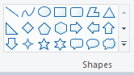



Good Luck

